Initial Rhyme

🔹 What is Initial Rhyme
# Source: AI Source: Provided by: [Data Path: Persons Table -> ID Column: 1, Name_En Column: Motasem Essam] -> From: [Chatgpt (GPT-4-turbo)] on [8/2/2025]
⚠️ Initial rhyme is a type of poetic rhyme, not a true type of homograph, but homographs may be used within it when appropriate.

✅ Definition of Initial Rhyme
# Source: AI Source: Provided by: [Data Path: Persons Table -> ID Column: 1, Name_En Column: Motasem Essam] -> From: [Chatgpt (GPT-4-turbo)] on [8/2/2025]
Initial rhyme occurs when the beginning sounds (usually consonants) of words rhyme — often through alliteration or partial rhyme at the start of words or lines.
It is also called head rhyme or alliterative rhyme, though not all alliteration qualifies as rhyme.

🧠 Key Feature
# Source: AI Source: Provided by: [Data Path: Persons Table -> ID Column: 1, Name_En Column: Motasem Essam] -> From: [Chatgpt (GPT-4-turbo)] on [8/2/2025]
- Focus is on the initial sounds (especially consonants), not the whole word.
- May occur within a line or at the beginning of successive lines.

📝 Examples of Initial Rhyme
# Source: AI Source: Provided by: [Data Path: Persons Table -> ID Column: 1, Name_En Column: Motasem Essam] -> From: [Chatgpt (GPT-4-turbo)] on [8/2/2025]
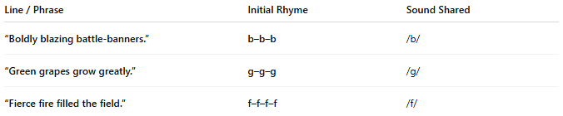
Line / Phrase | Initial Rhyme | Sound Shared
“Boldly blazing battle-banners.” | b–b–b | /b/
“Green grapes grow greatly.” | g–g–g | /g/
“Fierce fire filled the field.” | f–f–f–f | /f/

🧪 Example with Homographs
# Source: AI Source: Provided by: [Data Path: Persons Table -> ID Column: 1, Name_En Column: Motasem Essam] -> From: [Chatgpt (GPT-4-turbo)] on [8/2/2025]
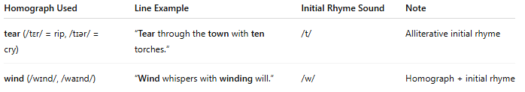
Homograph Used | Line Example | Initial Rhyme Sound | Note
tear (/tɛr/ = rip, /tɪər/ = cry) | “Tear through the town with ten torches.” | /t/ | Alliterative initial rhyme
wind (/wɪnd/, /waɪnd/) | “Wind whispers with winding will.” | /w/ | Homograph + initial rhyme

🧭 Relationship Between Homographs and Initial Rhyme
# Source: AI Source: Provided by: [Data Path: Persons Table -> ID Column: 1, Name_En Column: Motasem Essam] -> From: [Chatgpt (GPT-4-turbo)] on [8/2/2025]
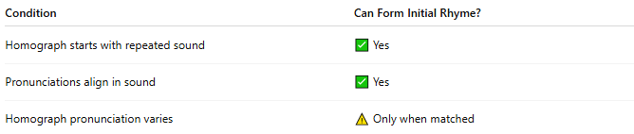
Condition | Can Form Initial Rhyme?
Homograph starts with repeated sound | ✅ Yes
Pronunciations align in sound | ✅ Yes
Homograph pronunciation varies | ⚠️ Only when matched

📊 Comparison Table
# Source: AI Source: Provided by: [Data Path: Persons Table -> ID Column: 1, Name_En Column: Motasem Essam] -> From: [Chatgpt (GPT-4-turbo)] on [8/2/2025]
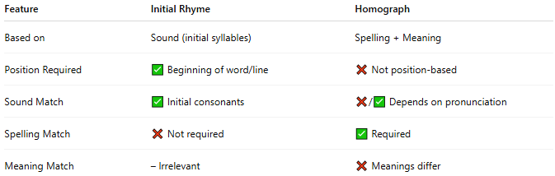
Feature | Initial Rhyme | Homograph
Based on | Sound (initial syllables) | Spelling + Meaning
Position Required | ✅ Beginning of word/line | ❌ Not position-based
Sound Match | ✅ Initial consonants | ❌/✅ Depends on pronunciation
Spelling Match | ❌ Not required | ✅ Required
Meaning Match | – Irrelevant | ❌ Meanings differ

✅ Summary
# Source: AI Source: Provided by: [Data Path: Persons Table -> ID Column: 1, Name_En Column: Motasem Essam] -> From: [Chatgpt (GPT-4-turbo)] on [8/2/2025]
- Initial rhyme emphasizes repeated starting sounds—mainly consonants.
- Homographs may appear in initial rhymes, especially in alliterative verse, when:
  - They share the same initial sound.
  - Their pronunciation matches the rhyme pattern.

